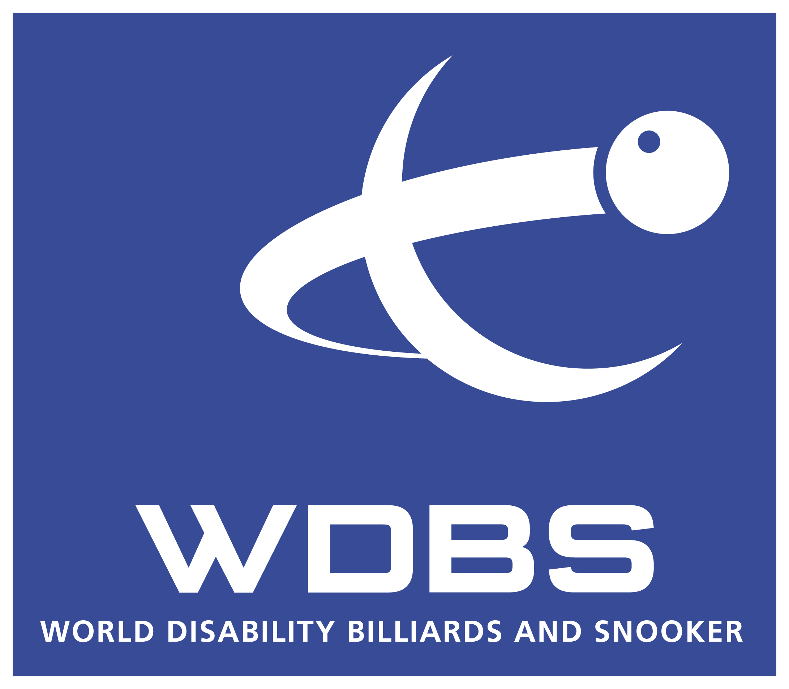
WDBS BELGIAN OPEN MINIBUS

15-17 March 2024

To help UK-based players travel to compete in the 2024 Belgian Open, WDBS will again operate a minibus service to/from Bruges. The minibus will leave England on the morning of Friday 15 March and will return on Monday 18 March. View further information HERE.

To register please complete and return the form below as soon as possible. Places will be taken on a first-come, first-served basis, with priority given to players and carers.

PLAYERS NAME ______________________________________

Total number of passengers ____________

Cost £100.00 Deposit due now £50.00 (balance due ………..)

Please pay via Bank transfer:

Bank Name: Natwest
Account Name: World Disability Billiards and Snooker
Account Number: 89089073
Sort Code: 52-10-03
For reference, please add your initials, followed by ‘BUS’. For example ‘CHBUS’

Address ________________________________________________________

________________________________________________________

Post Code _____________________ Telephone ________________________

Email address _________________________________________________________

Carer details _________________________________________________________
(if applicable)
_________________________________________________________

Preferred 8.00am East Riding Leisure Centre, North Street, Goole, DN14 5QX 
pick up
10.30am Barratts Snooker Club & Bar, Kingsthorpe Rd, Northampton NN2 6HT 

Signed _____________________________ Date _____________________

This form must be completed in full and emailed to Jessica.ives@wpbsa.com

